LBCC USER GUIDE FOR REQUISITION ENTRY

Requisition Online Entry PeopleSoft 9.2

Table of Contents

Entering Requisitions…………………………………………………………………………………………………………4

Printing Requisitions………………………………………………………………………………………………………… 11

Vendor Lookup…………………………………………………………………………….......................................14

Standard Comments………………………………………………………………………………………………………… 17

Multiple Chartfields…………………………………………………………………………………………………………. 22

Multiple Chartfields (Requisition Defaults)………………………………………………………………………. 27

Changing Requisition Information on the Defaults Panel…………………………………………………. 28
Getting Started

- Log in to PeopleSoft Financials 9.2 from www.lbcc.edu by clicking on the VIKING PORTAL.

- This will open the Viking Portal log in location for PeopleSoft Financials 9.2.
Enter your UserID (EmplID) along with your Password (Network password). REMEMBER the password is case sensitive. Click the Log In button. A One Time Passcode Required screen will pop-up, please enter the OTP to continue, then click the Log In button.

Check the box “Remember this device?”. Remembering this browser prevents extra login prompts. You should NOT enable this on public/shared computers.

- The Viking Portal page – Thor tab will open, click on the Financials tile.

- Click on the Requisition tile on your LBC Financials Homepage.

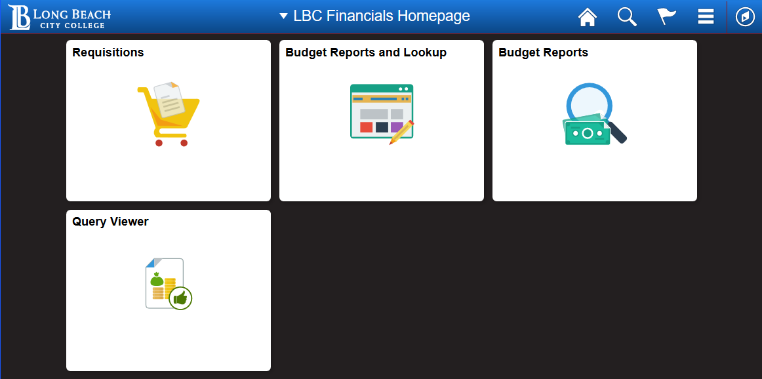

**IMPORTANT**
Please use ALL CAPS for ALL TEXT entered in the Requisition.

In order to complete your requisition, the fields below, numbered 1-5 must be filled in.

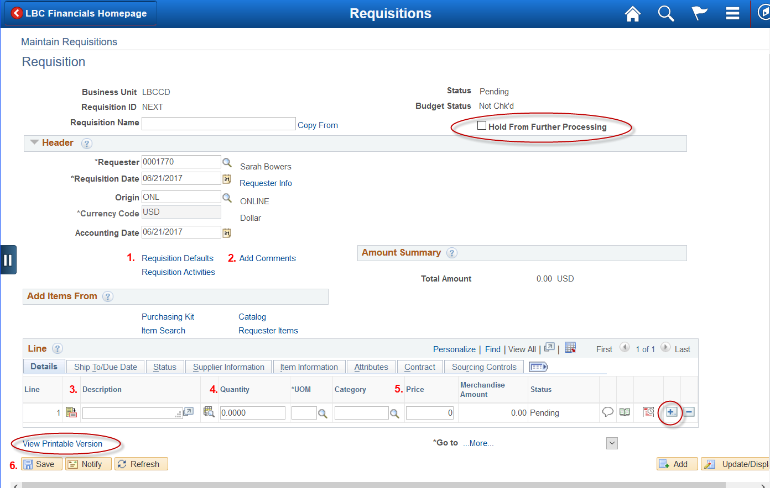

Entering Requisitions

- On the Add a New Value tab, click the Add button to create a new Requisition.
NOTE: The Requisition ID defaults to NEXT. DO NOT TYPE IN THIS FIELD!

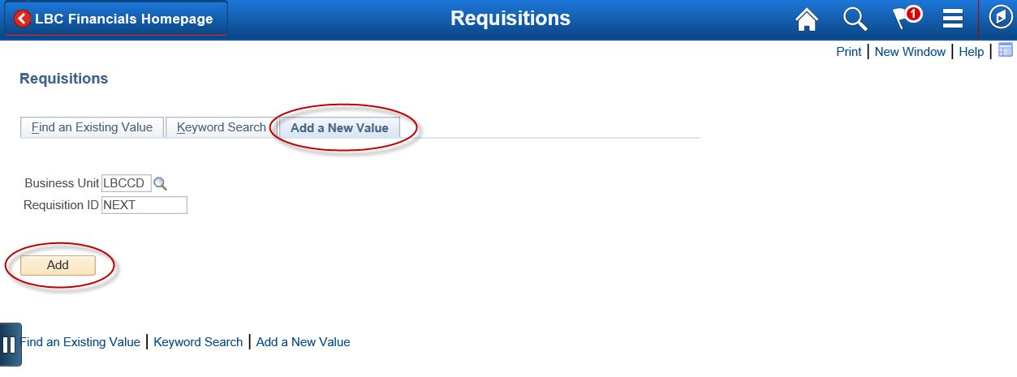

- Click on the Requisition Defaults link.

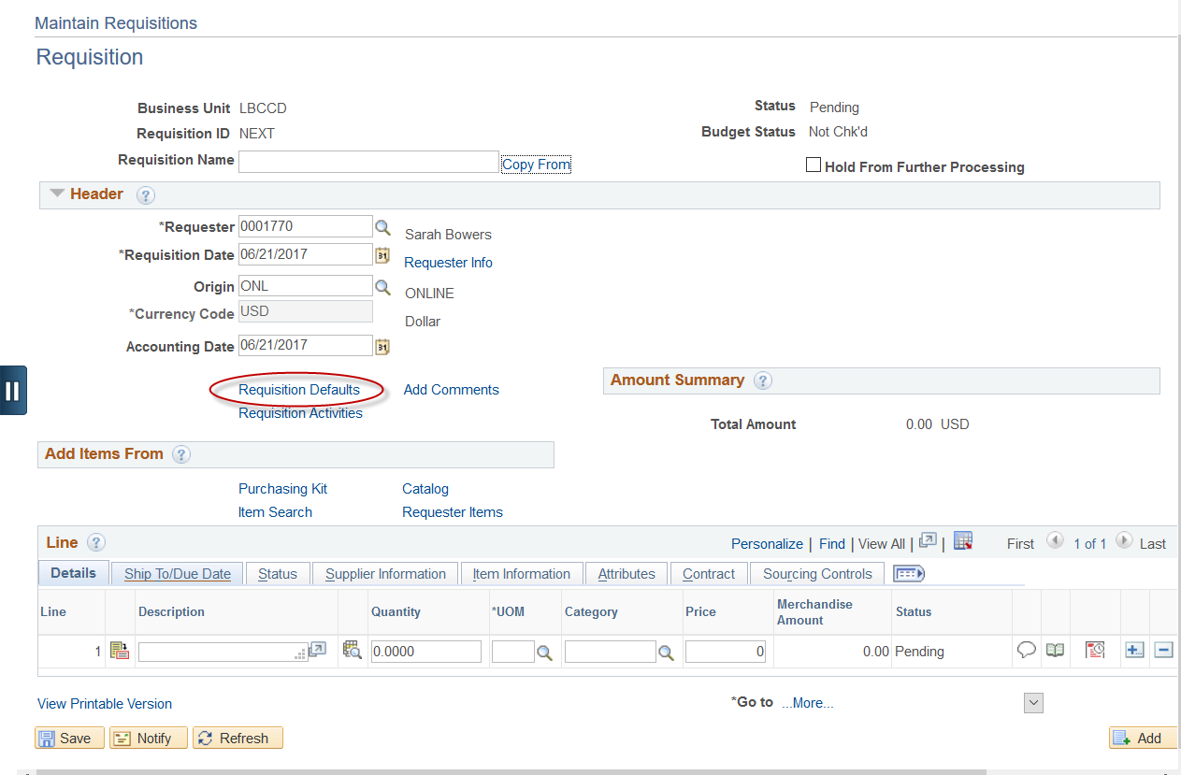

- On the Requisition Defaults page:
First, click the Override button.
Next, enter Vendor (Supplier), Category, Unit of Measure, and Ship To fields. Use the magnifying glass for selecting these items.
Last, fill in your Account, Fund, Dept., and Program. Click the OK button.

>>NOTE: The information entered here will default onto every line of the requisition but can be changed if necessary at the individual line level.

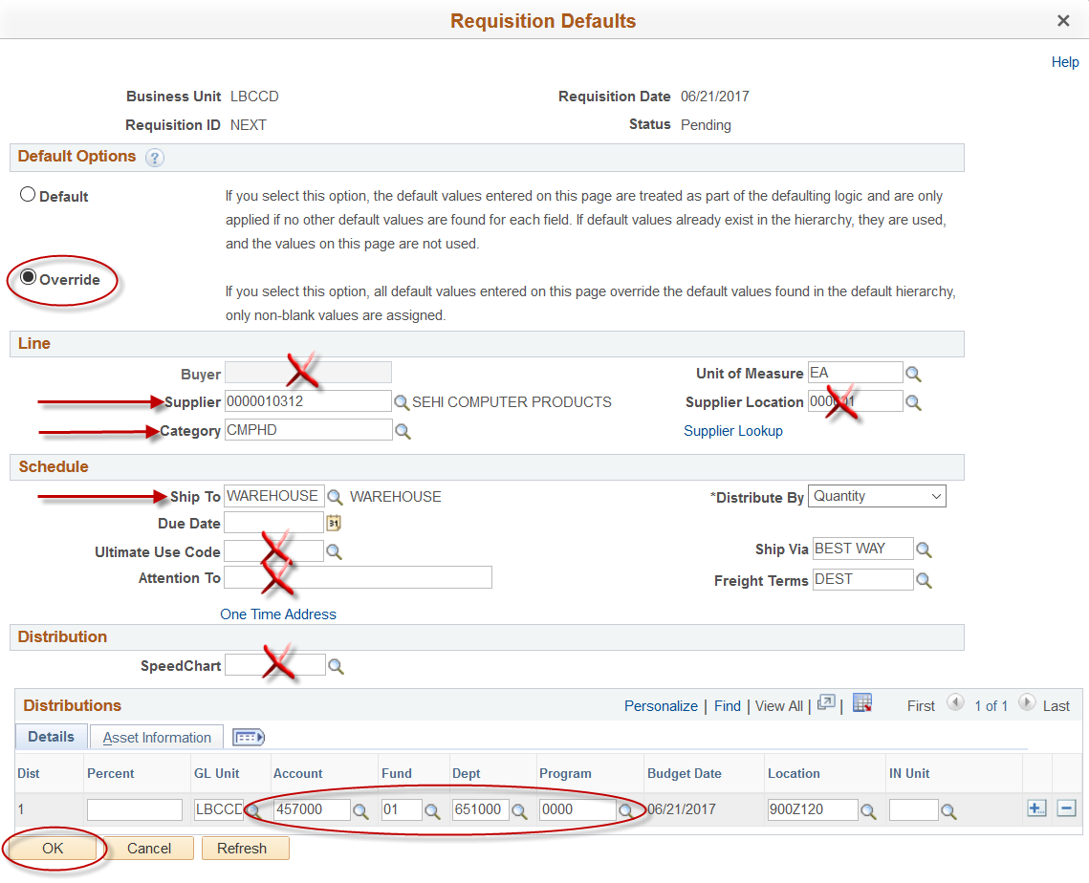

IMPORTANT:
The Category field is for describing the TYPE OF PURCHASE you are making and NOT the area or department where you work. >>> Select only 1 category per requisition. <<<

- To add Header comments click on the Add Comments link. Comments entered here pertain to the entire Requisition.

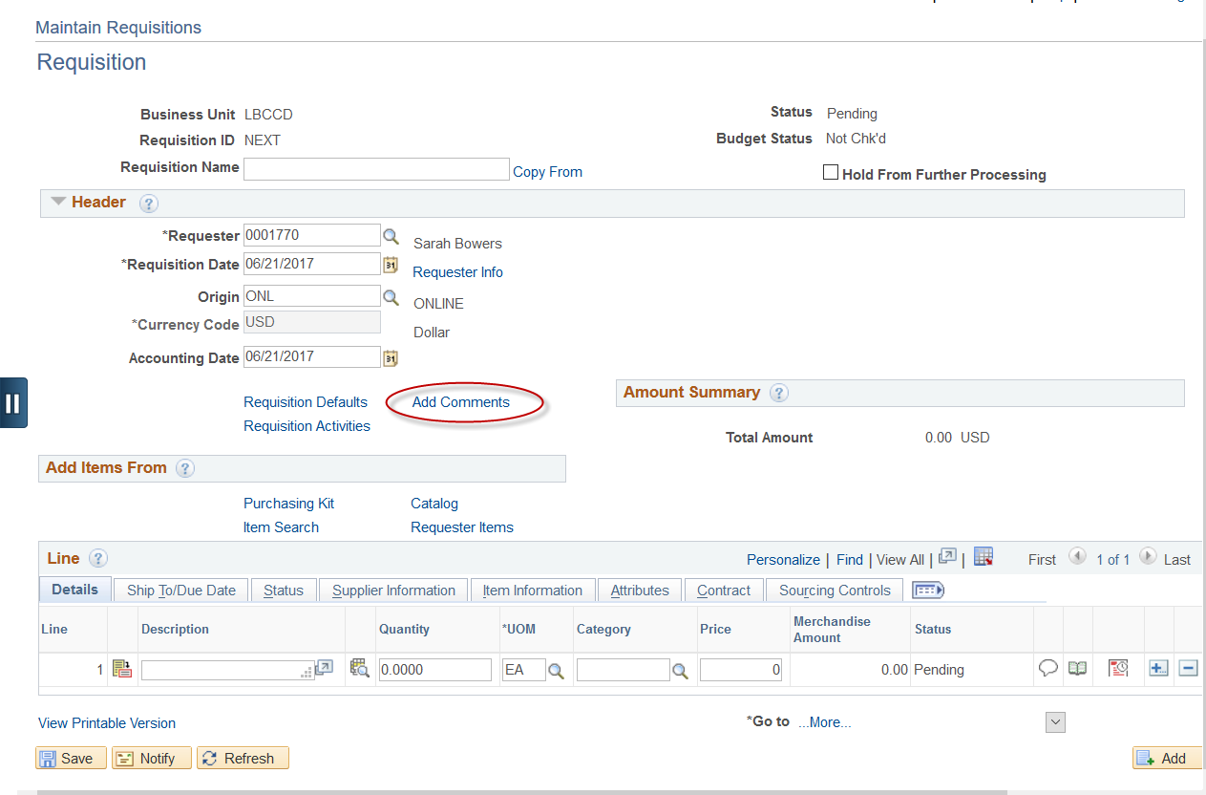

- Add Header comments then click the OK button. If there are documents that need to be attached, use the button then Browse and select the document to attach.
>>NOTE: Multiple documents can be attached by clicking on the Add button

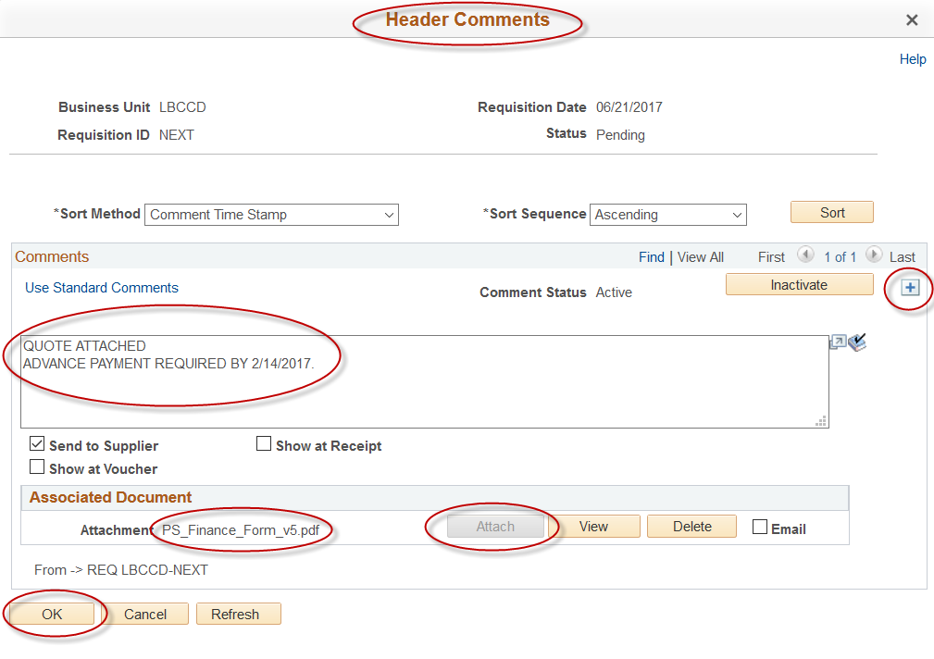

- Enter your first item on Line 1 with the Description, Quantity, and Price.
Click the Refresh button (lower left side) and the additional information from the Defaults page will fill in (UOM, Category).
Begin your Description with the basic descriptive word of what is being requested (ex: Computer, Printer, Table). Followed by the item or catalog #, size, color, etc.

Click the 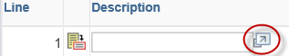 arrow button to the right of the Description line field to view the entire description. You can modify the line item description here if needed. (There is a limit of 254 characters.)

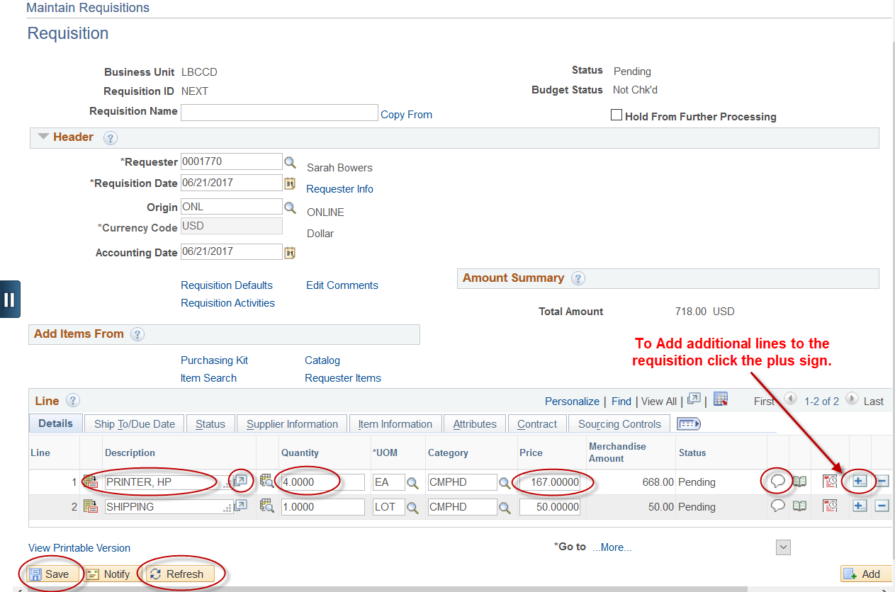

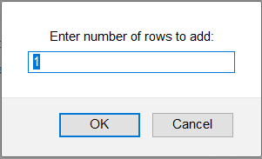

>>NOTE: Additional information specific to each line can be entered in the Line Comments
- Click on Save and a Requisition ID will be assigned. If you are not finished and want to add or change something on the requisition, check the Hold From Further Processing box and click the Save button again.

If you are completely finished entering information in the Requisition then make sure the Hold box is unchecked and click the Save button again, so that the requisition is picked up by the workflow process and sent on for approvals.

NOTE: DO NOT MAKE ANY CHANGES TO A REQUISITION AFTER IT HAS BEEN PICKED UP BY WORKFLOW AND SENT FOR APPROVALS
(This process runs at night for requisitions that are not on Hold)

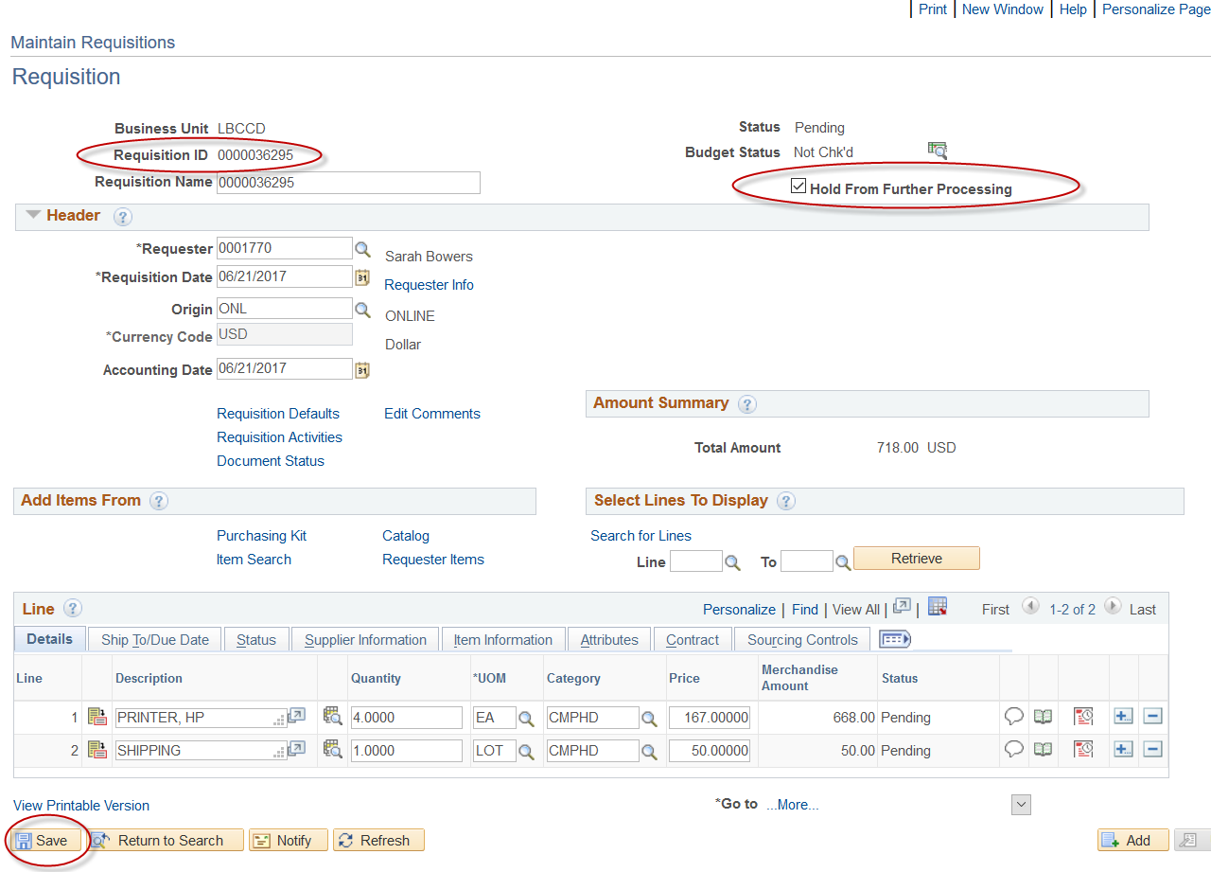

IMPORTANT: ONLINE REQUISITIONS WILL BE AVAILABLE IN THE WORKLIST OF YOUR ADMINISTRATOR FOR APPROVAL THE NEXT DAY AFTER YOU HAVE ENTERED THE REQUISITION.

- To Print the Requisition, click on View Printable Version.

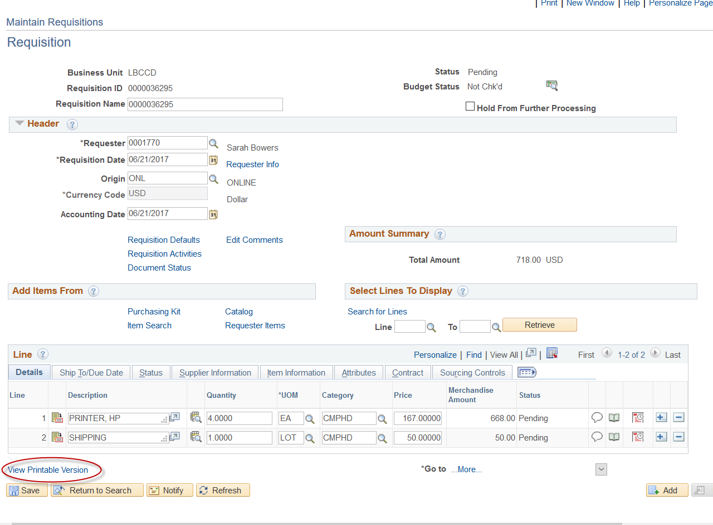

- If the message below appears then click Yes to save the document and continue. (This message may not appear.)

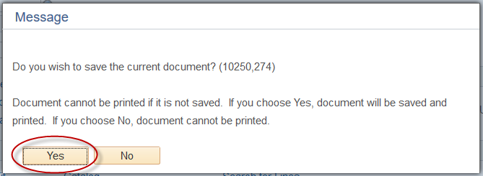

- After clicking the View Printable Version link, the process to print the Requisition starts.

NOTE: You can also access the Requisition and all of your reports by clicking the Requisition tile and then Reporting Tools to access the Report Manager.

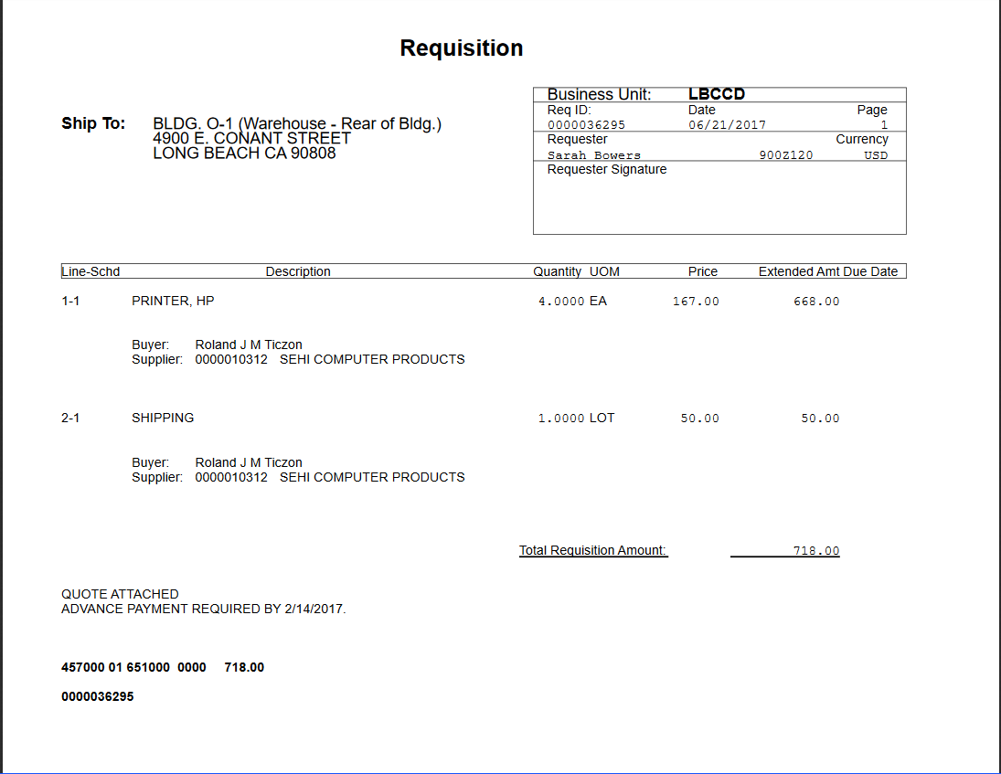

- From the Administration tab click the Refresh button until the Status is Posted and the Details link shows to the right of Posted. In the Report Manager panel the current document or report will always be at the top of the Report List. To view the requisition click directly on the Requisition Print SQR link.
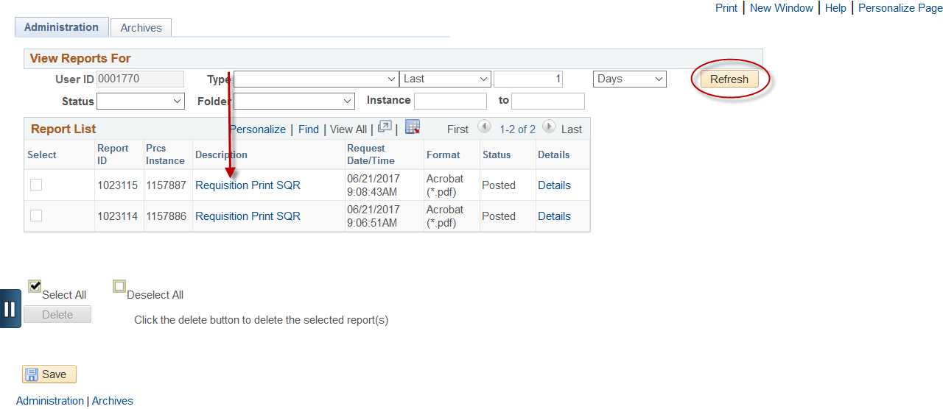

- From the Requisition Adobe format you can either, Print, Save, or Email the Requisition.

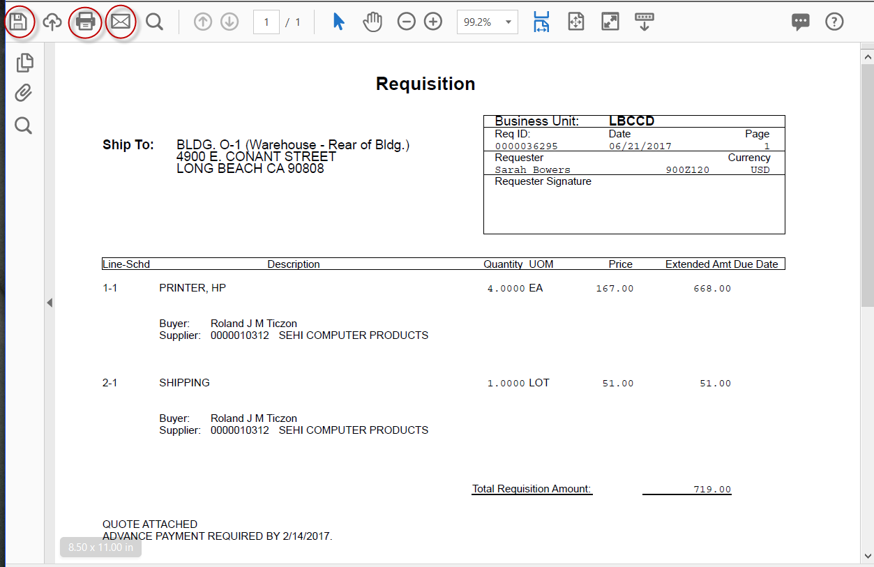
Supplier Lookup

- On the Requisition Defaults page click on the magnifying glass to open panel to search for a vendor.

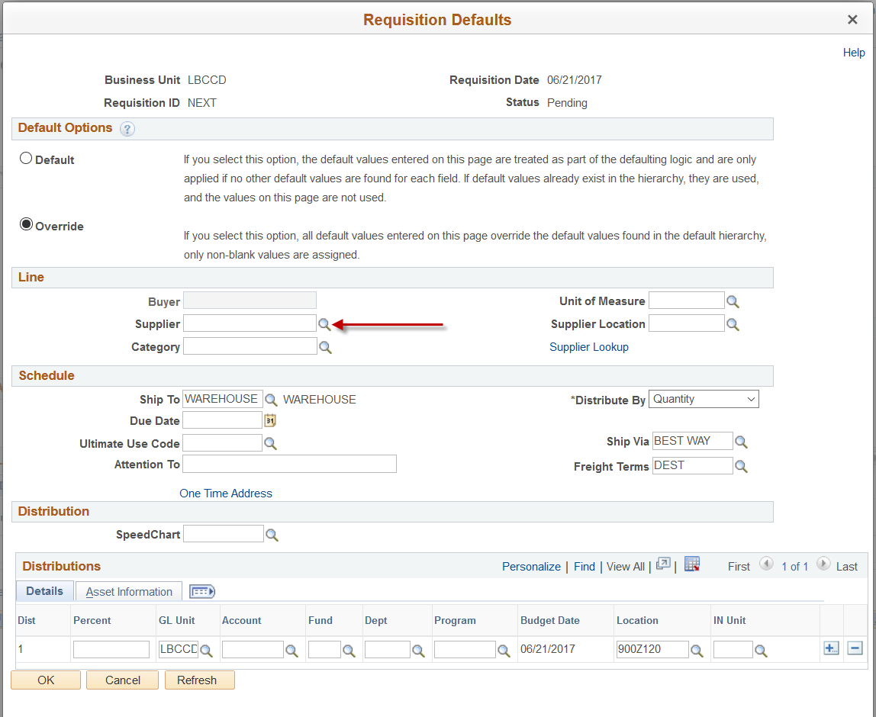

- Enter the first few letters of the vendor name in the Short Supplier Name field. The maximum number of letters is ten.

>>NOTE: There is no space between vendor names under the Short Supplier Name field; eg. OFFICEDEPO. Next click the Look Up button.

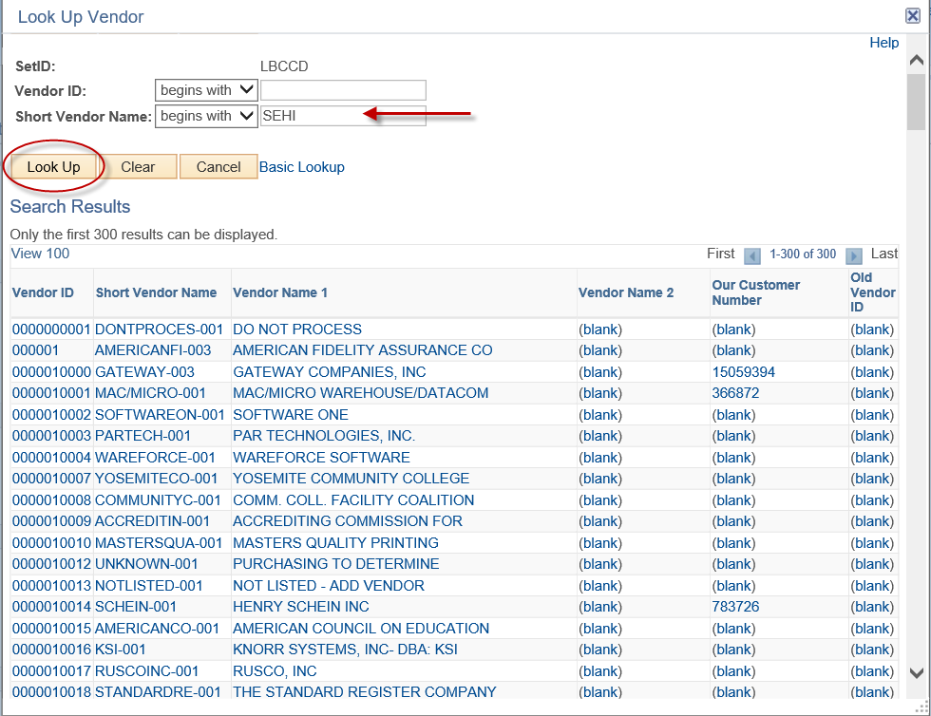

- Click on the vendor selected and the vendor name and information will fill in on the Requisition Defaults page.

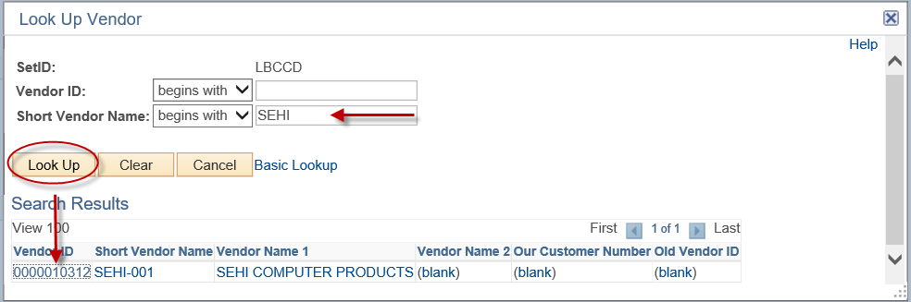

- If the vendor is not in the database of vendors, then select the name NOTLISTED as the vendor, click Look Up and select it. If the vendor is not known at all then select UNKNOWN as the vendor name and Purchasing will determine the vendor.

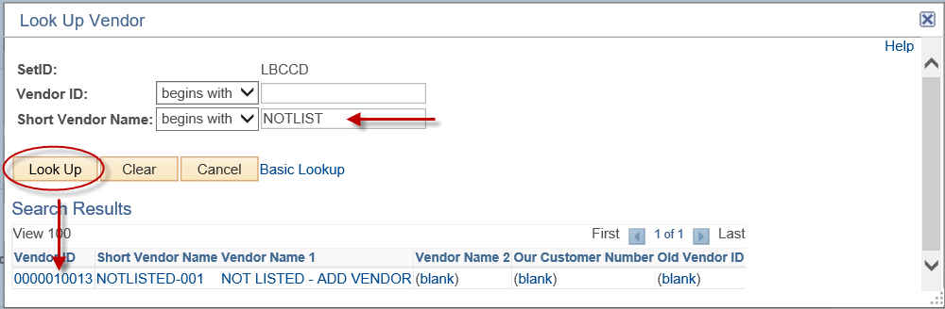

>>NOTE: NEW VENDOR REQUIREMENTS - If this is a new vendor, provide the name, address, and phone # along with any contact person’s name in the Header Comments panel of the Requisition. Within the Header comment field, attach a completed W-9.

Standard Comments

- To add a standard comment to your Requisition, click on the Add Comments link.

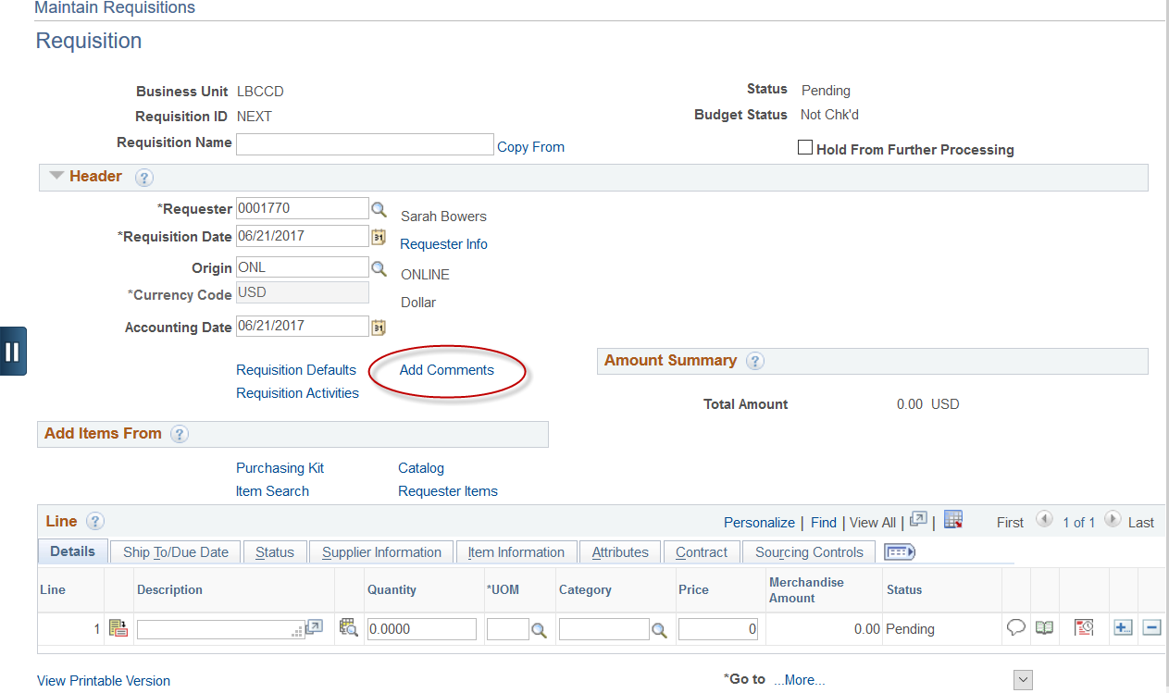

- Click on the Use Standard Comments link.

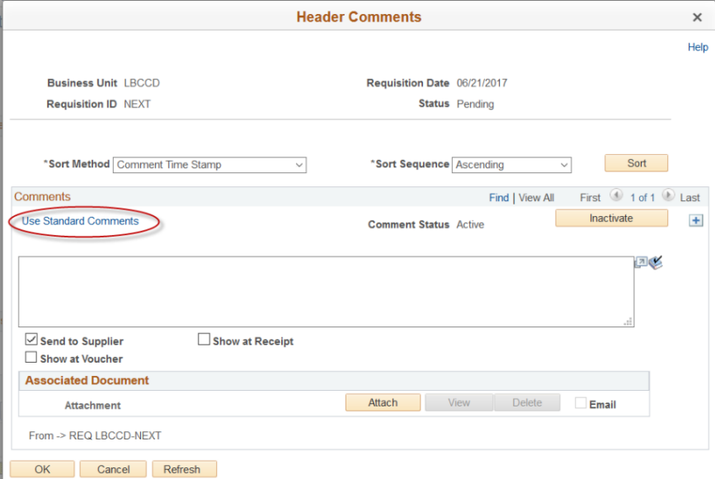
- Click on the magnifying glass for Comment Type.

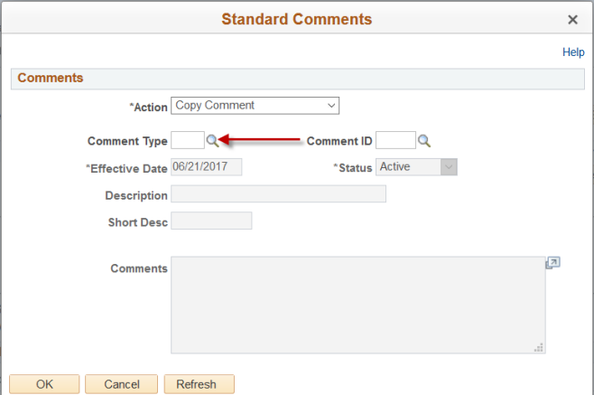

- Select the Standard Comment Type TMP for TEMPLATE COMMENT.

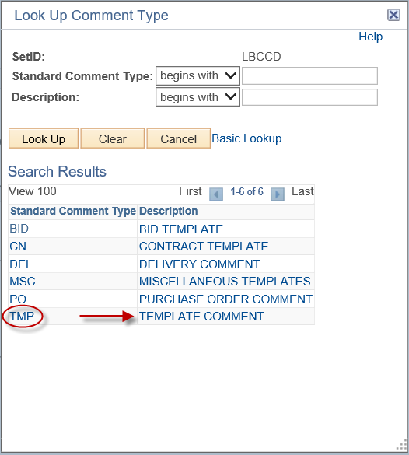

- Next click on the magnifying glass for Comment ID.

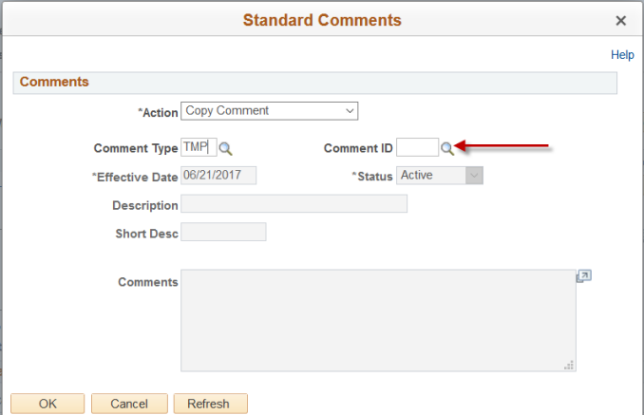

- Select Comment ID as OPEN for OPEN PO TEMPLATE.

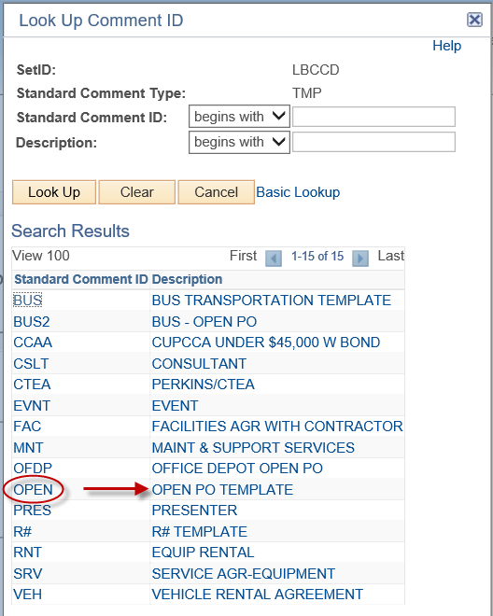
- Click the OK button.
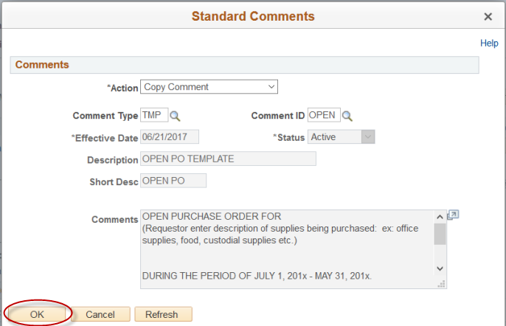

- In ALL CAPS, insert information where the lower case type appears. Scroll down to view the whole text, and add information where needed. Click OK.

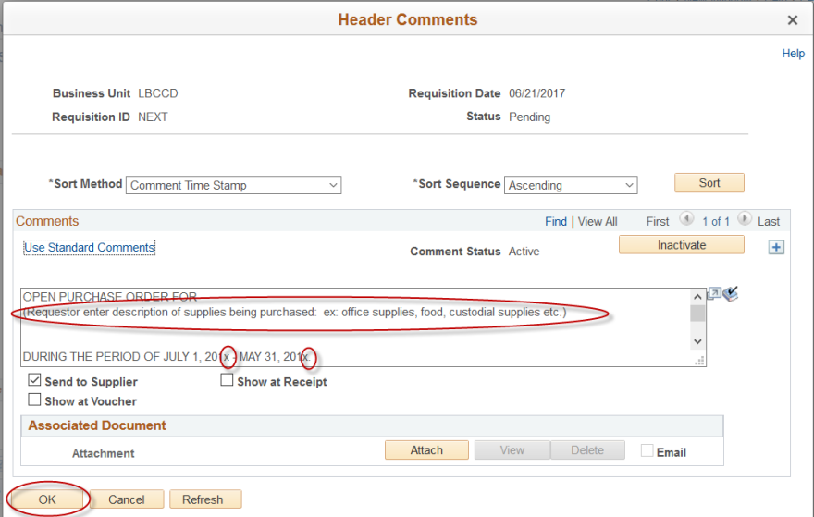
>>NOTE: Additional templates are available (see item #22 for listing of additional choices). Select as needed. If multiple comments are needed, click the button.

Multiple Chartfields (Accounts)

- Line items can be distributed to multiple chartfields (accounts) by either dollar amount or by percentage. To split line item by dollar amount between two or more multiple accounts click on the Schedule button for the line. NOTE: Dollar amount for the line.
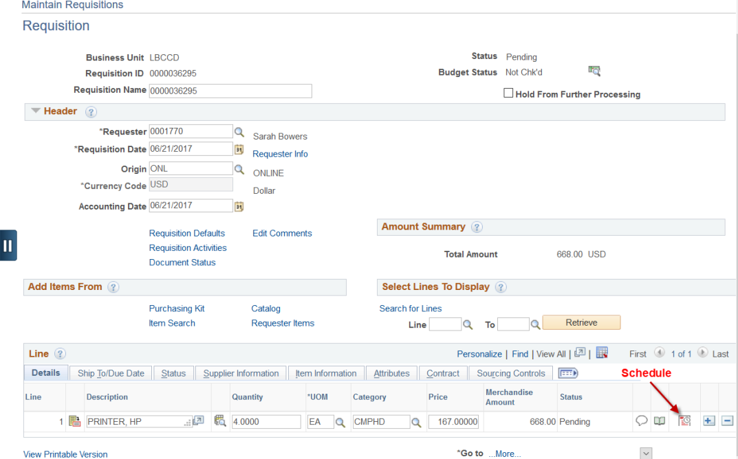

- Click on the Distribution button.
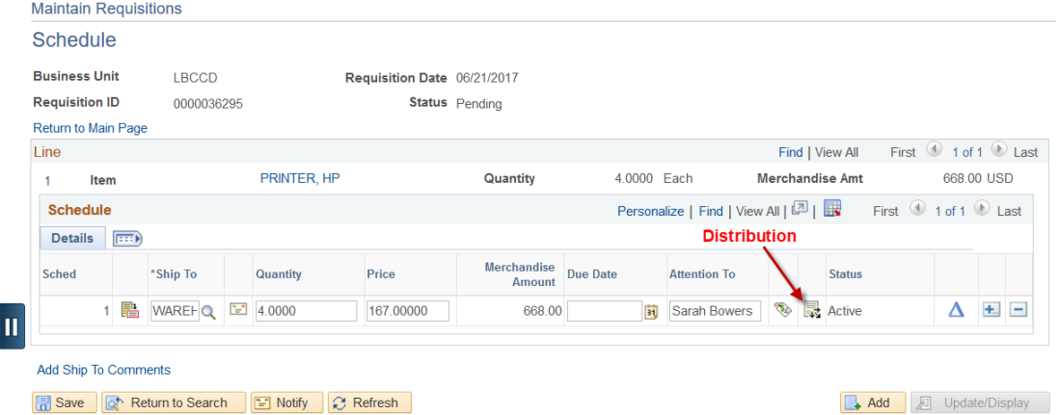

- Change the Distribution to Amount. Enter the dollar amount and the first chartfield account code then click Refresh. Next click the button to add a second row.

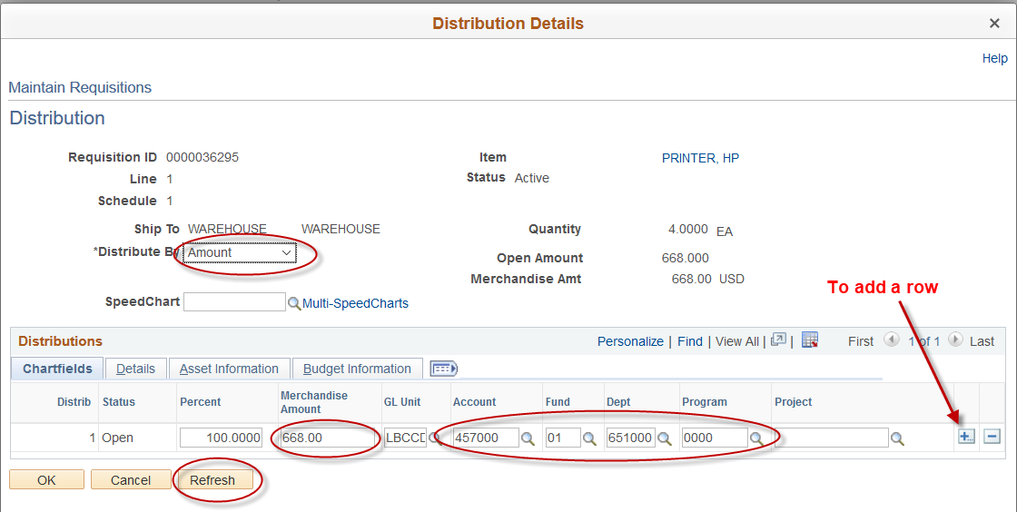

Click OK to add the line.

- The remaining dollar amount fills in automatically. Enter the 2nd account code for the 2nd line. Click OK.

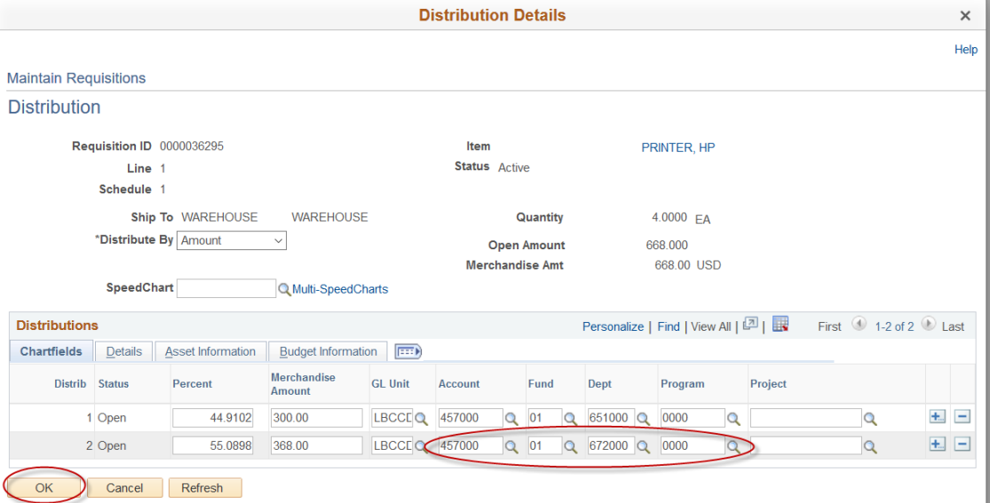

- To split the line item by a percentage between multiple accounts, click on the Schedule button.

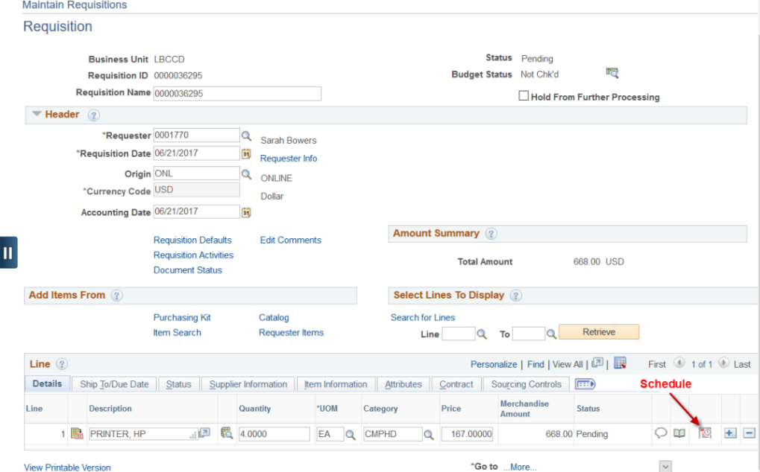

- Click on the Distribution button.

- Distribution stays at Quantity. Enter a percentage and the first chartfield account code then click Refresh. Next click the button to add a second row.
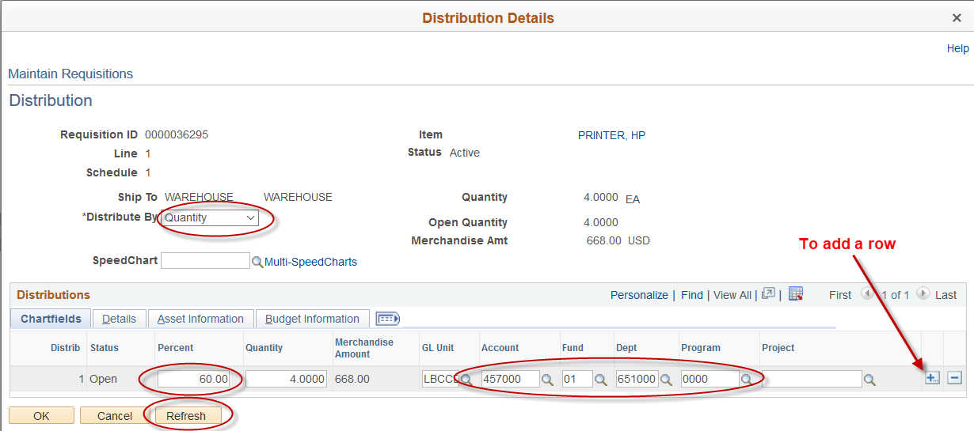

Click OK to add the line.

- The remaining dollar amount by the percentage fills in automatically. Enter the 2nd account code for the 2nd line. Click OK.

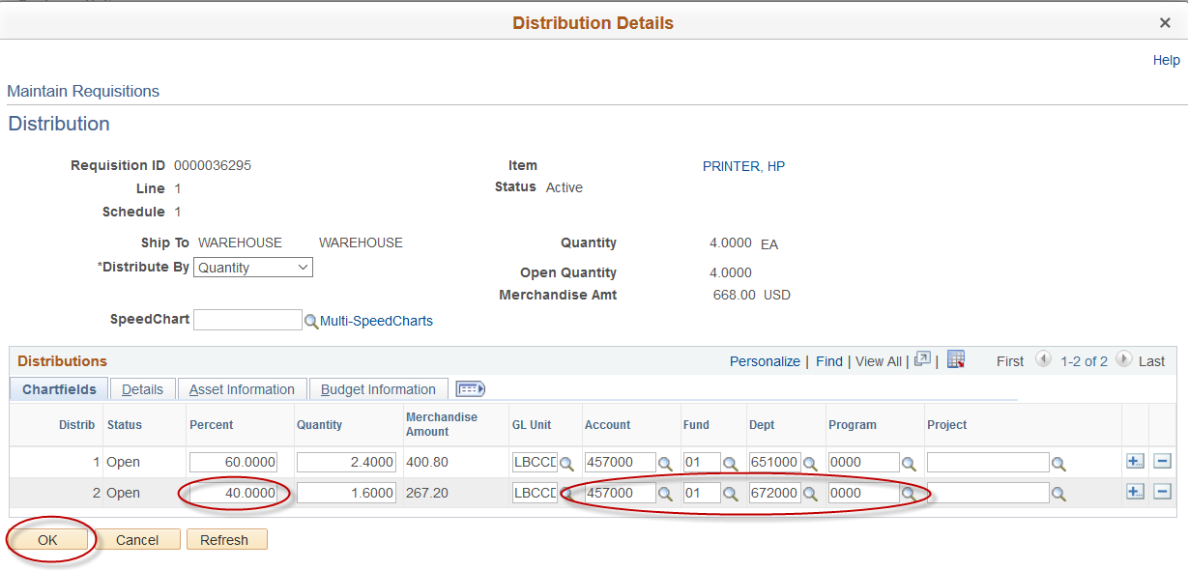

>>NOTE: Be sure to click the Save button after any changes are made to the Requisition.

Entering Multiple Chartfields (Accounts) - Requisition Defaults page.

- NOTE: Account numbers entered here can only be split by percentage and will be distributed to all lines on the requisition. Enter a percentage and the first chartfield account. Next click on the button and fill in the remaining percentage and next account. Click OK.

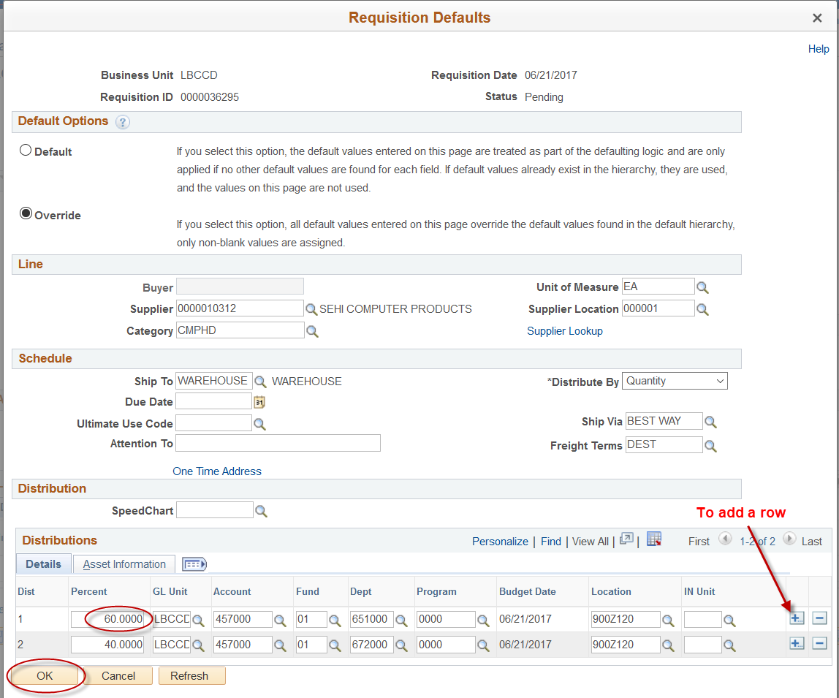

Changing Requisition Information on the Defaults Panel.

NOTE: These changes will apply to all lines on the requisition and can only be made up to 5:00 p.m. on the day that the requisition has been entered unless the requisition is on hold.

- From the Requisitions Menu, select Add/Update Requisitions. Enter Requisition number and then select Requisition Defaults.

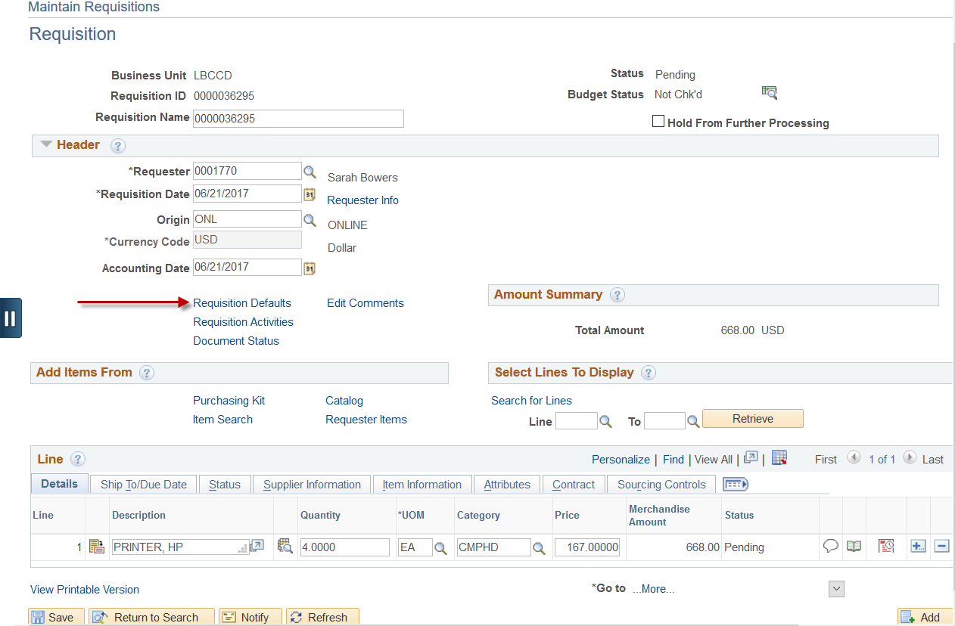

- Change the default information. In this example, the account field was changed then click the OK button.
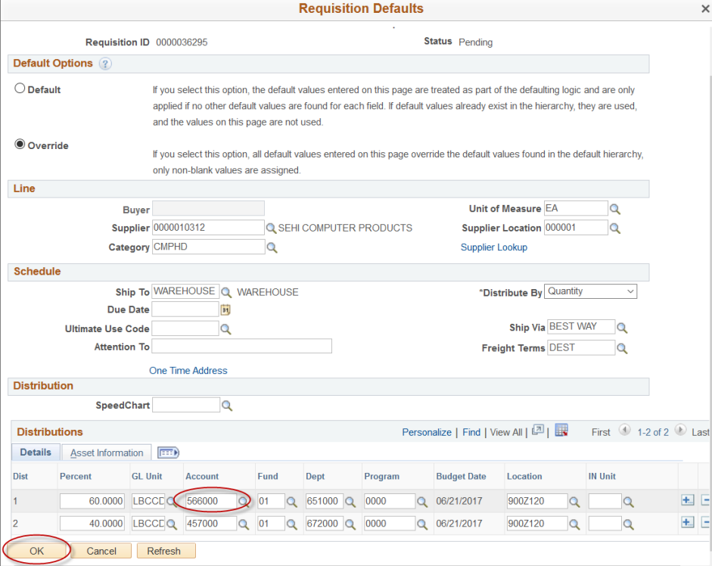

- Click the Mark All link and a check mark appears in the Apply column. Next click the OK button and Save.
